Exposure Control Plan for COVID-19 (Coronavirus)

Company information

[name]
[address]
[contact information (names and phone numbers)]

Health hazards of COVID-19

COVID-19 has been declared a global pandemic and a public health emergency in British Columbia. is a virus that can cause respiratory illness and can lead to hospitalization and death. The effects of COVID-19 are expected to be much more severe than for seasonal influenza because most people will not have any immunity to the virus. Seniors and people with underlying health issues (including heart disease, diabetes and lung disease) are at a higher risk of hospitalization and death, but young and healthy people are also at risk.

Symptoms

Symptoms of COVID-19 are likely to include fever, cough, sneezing, sore throat and difficulty breathing.

Transmission

Exposure to COVID-19 can occur by:
- Breathing in droplets in the air that are generated when people cough or sneeze
- Close contact with other people (e.g. shaking hands or hugging)
- Touching contaminated surfaces and then touching the face, mouth, or food.

Note that touching a contaminated surface and then touching another surface may cause the virus to transfer from one surface to another

COVID-19 can be transmitted even by people who are not displaying symptoms of the disease. People who may be infected with COVID-19 should not come to work. This includes people who:
- Have symptoms of COVID-19
- Have travelled outside of Canada with then previous 14 days
- Have been exposed to someone with COVID-19
- Share a home with someone who has symptoms of COVID-19
- Share a home with someone who has been exposed to COVID-19

Statement of purpose

Our company is committed to providing a safe and healthy workplace for all of our staff. A combination of measures will be used to minimize worker exposure to COVID-19, including the most effective control technologies available. Our work procedures will protect not only our workers, but also other workers who enter our facilities. All employees must follow the procedures outlined in this plan to prevent or reduce exposure to COVID-19.

Responsibilities

Employer responsibilities

Our company will:
- Ensure that the materials (for example, gloves, alcohol-based hand rubs, and washing facilities) and other resources (for example, worker training materials) required to implement and maintain the plan are readily available where and when they are required.
- Ensure that workers are able to maintain social distancing (2 meters apart) at all times while completing their work safely.
- Select, implement, and document the appropriate site-specific control measures.
- Ensure that supervisors and workers are educated and trained to an acceptable level of competency.
- Ensure that workers use appropriate personal protective equipment (PPE) — for example, gloves, gowns, eye protection, and respirators.
- Conduct a periodic review of the plan’s effectiveness. This includes a review of the available control technologies to ensure that these are selected and used when practical.
- Maintain records of training and inspections.
- Ensure that a copy of the exposure control plan is available to workers.

Supervisor responsibilities

Our supervisors will:
- Ensure that workers are adequately instructed on the controls for the hazards at the location.
- Ensure that workers use proper respirators, they have been fit tested, and the results are recorded.
- Ensure that social distancing is maintained.
- Direct work in a manner that eliminates or minimizes the risk to workers.

Worker responsibilities

Our workers will:
- Maintain social distance
- Know the hazards of workplace.
- Follow established work procedures as directed by the employer or supervisor.
- Use any required PPE as instructed.
- Report any unsafe conditions or acts to the supervisor.
- Know how and when to report exposure incidents.

Risk identification and assessment

Three primary routes of transmission are anticipated for COVID-19, all of which need to be controlled. These include contact, droplet, and airborne transmission.

Breathing in droplets in the air

CCDC advises that coronavirus is not transmitted through airborne transmission, however, if somebody coughs or sneezes they do generate droplets which are airborne for at least a short period of time but do not float in the air and generally fall to the ground within one to two meters. Anybody who is near the individual may risk breathing in these droplets. Social distancing (maintaining 2 meters of distance from other people at all time) will reduce the risk of this occurring.

Close contact

Close contact refers to physical contact with another person, for example shaking hands or hugging. When people cough or sneeze droplets may deposit on their skin or clothing, especially if they cough or sneeze into their hands. People who are carriers of COVID-19 may transfer the virus from their hands or clothing to others during close contact.

Surface contact

Surfaces can become contaminated when droplets carrying COVID-19 deposit on them, or when they are touched by a person who is infected. Surface contact involves a worker touching a contaminated object such as a table, doorknob, telephone, or computer keyboard or tool, and then touching the eyes, nose, or mouth. Surface contact is important to consider because COVID-19 can persist for several days on surfaces.

The following risk assessment table as a reference guideline, we have determined that the risk level of our workers is low when they maintain social distancing. Our workers work on a construction work site and have little contact with the general public.

Risk assessment for COVID-19

 | Low risk  Workers who typically have no contact with people infected with COVID-19 | Moderate risk  Workers who may be exposed to infected people from time to time in relatively large, well ventilated workspaces | High risk  Workers who may have contact with infected patients, or with infected people in small, poorly ventilated workspaces
Hand hygiene | Yes (washing with soap and water, using an alcohol-based hand rub, or using hand wipes that contain effective disinfectant) | Yes (washing with soap and water, using an alcohol-based hand rub, or using hand wipes that contain effective disinfectant) | Yes (washing with soap and water, using an alcohol-based hand rub, or using hand wipes that contain effective disinfectant)
Disposable gloves | Not required | Not required (unless handling contaminated objects on a regular basis) | Yes in some cases (for example, when working directly with COVID-19 patients)
Aprons, gowns, or similar body protection | Not required | Not required | Yes in some cases (for example, when working directly COVID-19 patients)
Eye protection - goggles or Face shield | Not required | Not required | Yes in some cases (for example, when working directly with COVID-19 patients)
Airway Protection - respirators | Not required | Not required (unless likely to be exposed to coughing and sneezing) | Yes (minimum N95 respirator or equivalent)

Risk control

The Regulation requires employers to implement infectious disease controls in the following order of preference:

- Engineering controls
- Administrative controls
- Personal protective equipment (PPE).

It is not necessary to implement engineering controls in our workplace because the risk of exposure can be controlled using administrative controls (for example, social distancing, hand washing, surface cleaning and cough/sneeze etiquette) and PPE (respirators).

Hand washing

Hand washing is one of the best ways to minimize the risk of infection. Proper hand washing helps prevent the transfer of infectious material from the hands to other parts of the body—particularly the eyes, nose, and mouth—or to other surfaces that are touched.
Wash your hands immediately:
- Before leaving a work area
- After handling materials that may be contaminated
- Before eating, drinking, smoking, handling contact lenses, or applying makeup.

Hand washing procedure

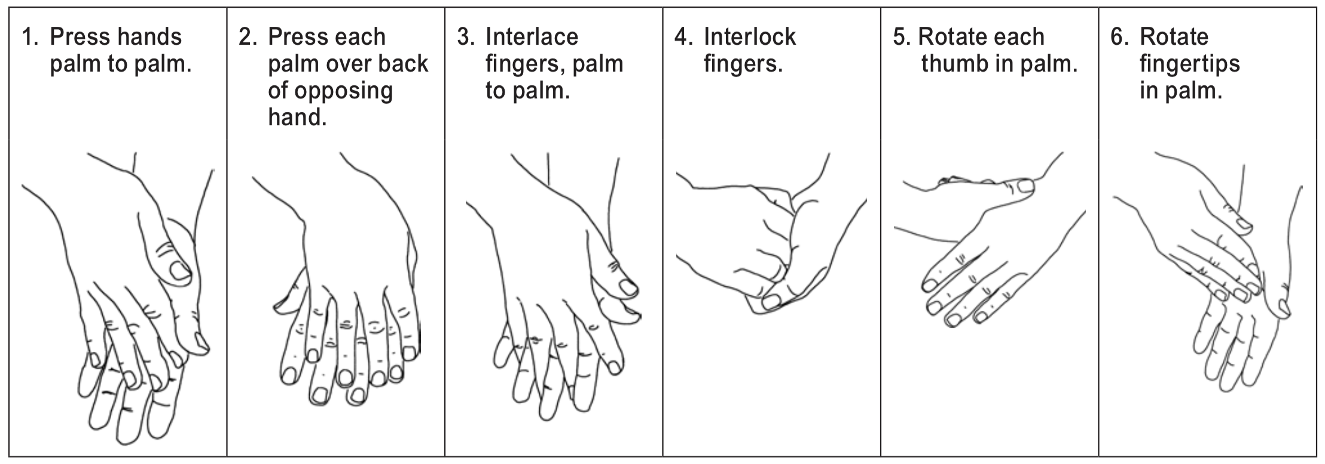

Use soap and warm running water. (It doesn’t have to be hot to do the job.) If water is unavailable, use a waterless hand cleanser that has at least 70% alcohol. Follow the manufacturer’s instructions on how to use the cleanser. Alcohol-based hand rub dispensers are located adjacent to the washrooms and kitchen area.

Cough/sneeze etiquette

Our workers are expected to follow cough/sneeze etiquette, which is a combination of measures that minimizes the transmission of diseases via droplet or airborne routes. Cough/sneeze etiquette includes the following components:
- Educate workers in control measures, including hand washing.
- Post signs at entry points to instruct everyone about control measures.
- Cover your mouth and nose with a sleeve or tissue when coughing or sneezing.
- Use tissues to contain secretions, and dispose of them promptly in a waste container.
- Offer surgical masks to people who are coughing.
- Turn your head away from others when coughing or sneezing.
- Wash hands regularly.

If workers show symptoms of COVID-19

If workers are ill with COVID-19, they should stay home. If they develop symptoms of COVID-19 while at work, they should leave the workplace. Workers should only return to the workplace once they have recovered from COVID-19. Workers should inform their manager or supervisor if they are ill with COVID-19.

Workers who suspect they may have COVID-19 should use the SK Self-Assessment Tool: COVID-19 Self Assessment Tool Home or call 811 for assistance.

Worker training

Our workers will receive training in the following:
- The risk of exposure to COVID-19, and the signs and symptoms of the disease
- Safe work procedures to be followed, including hand washing, social distancing and cough/sneeze etiquette
- Location of washing facilities, including dispensing stations for alcohol-based hand rubs
- How to seek first aid
- How to report an exposure to or symptoms of COVID-19.

Health monitoring

Our workers will promptly report any symptoms of COVID-19 to their manager or supervisor and the first aid attendant.

Record keeping

Our company will keep records of instruction and training provided to workers regarding COVID-19, as well as exposure reports and first aid records.

Annual review

We will review the exposure control plan every year and update it as necessary, in consultation with our joint health and safety committee or worker health and safety representative.

