SAFETY NOTICE FOR WORKERS
CORONAVIRUS (COVID – 19)

WHAT IS CORONAVIRUS (COVID-19)
- COVID-19 is a virus that can cause illness ranging from a cold-like illness to a severe lung infection. In some cases it can cause hospitalization and death.
- Symptoms may appear between 2 days to 14 days after being exposed.
- People can spread the disease even before they start showing symptoms.
Key Prevention Steps:

1. Social Distancing: Stay 2 meters away from other people on-site

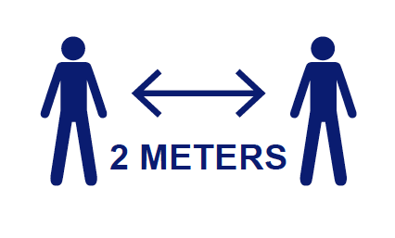

2. KEEP YOUR MIND ON YOUR TASK!

This is very important for all workers to remember during this pandemic. Keeping your mind on your task is critical to prevent any incidents from happening.

Things are changing daily. You should expect daily communications from your employer and to be prepared that you may be expected to change your routines.

Some examples of that are:
- Enforcing social distancing
- Cleaning and disinfecting your tools and work surfaces after every use
- Temperature checks from First Aid Attendants
- Wellness questions being asked to ensure you are not sick before entering sites or random checks
3. FOLLOW THESE TIPS:

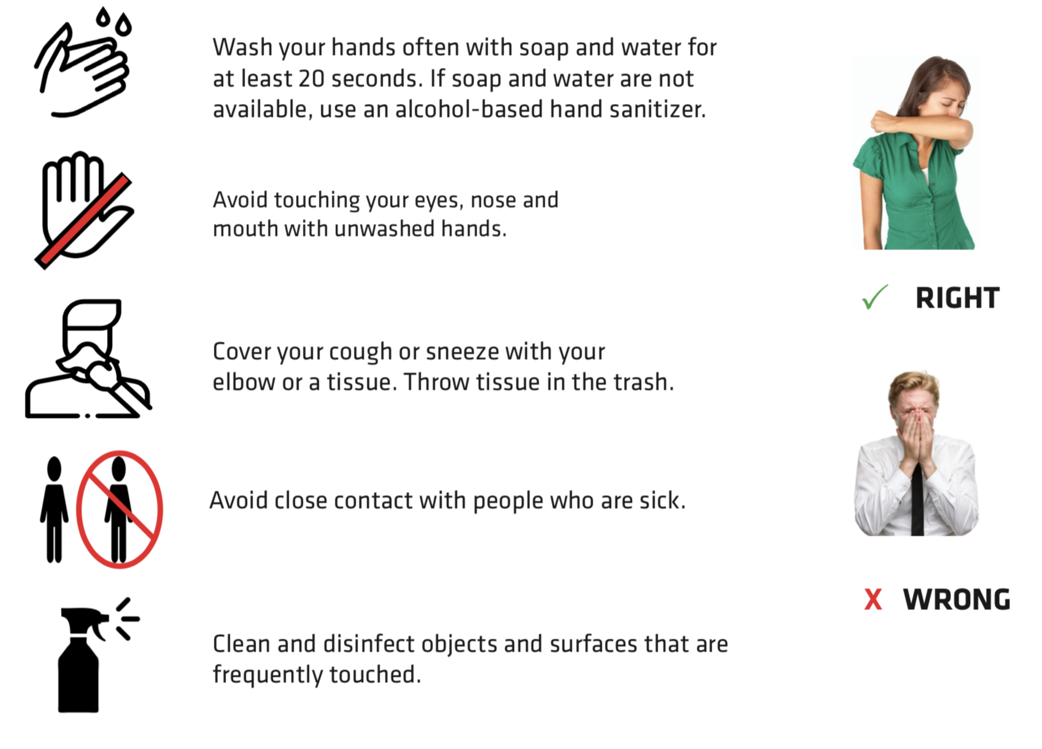

Stay home when you are sick!
Stay home when someone you live with is sick!
WHAT ARE THE SYMPTOMS

How does COVID-19 Spread?
- Breathing in droplets in the air that are created when people cough or sneeze
- Close contact with other people (e.g. shaking hands or hugging)
- Touching contaminated surfaces and then touching the face, mouth, or food.

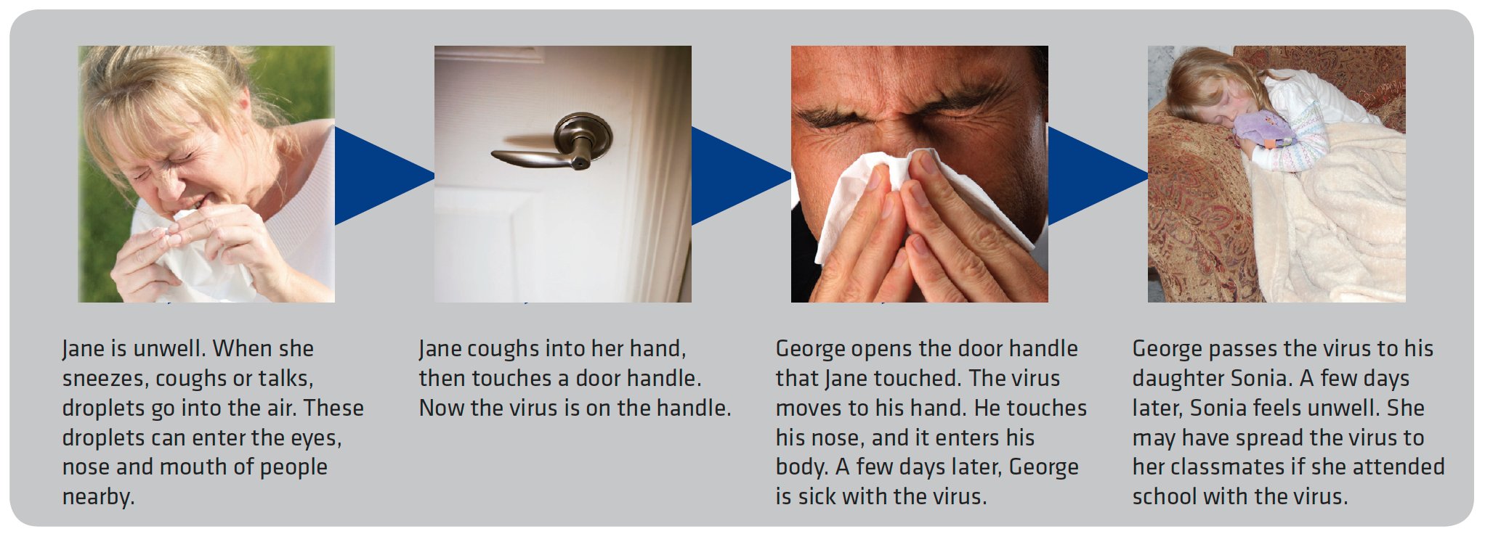

What should you do if you have symptoms or have been exposed?

Use the Sask.ca Self Assessment Tool: https://www.saskatchewan.ca/government/health-care-administration-and-provider-resources/treatment-procedures-and-guidelines/emerging-public-health-issues/2019-novel-coronavirus/covid-19-self-assessment

If you have any symptoms, isolate yourself from others as quickly as possible.

If you have been in close contact with someone who is being tested for COVID-19 or has tested positive, stay home and monitor yourself for symptoms and take your temperature every day.

